**Name: SHAMJAD MAZOOD NAZER**

**Roll No: 36**

**Batch: B**

**Date: 31-03-2022**

**NETWORKING & SYSTEM ADMINISTRATION LAB**

**Experiment No.: 4**

**Aim**

Familiarization of Linux Commands – Part 02

**Procedure**

1. **cut -d ‘delimiter’ -f(column number) [filename]:** This command is used to cut & print the details of the mentioned file according the delimiter specified and column number.E.g., cut -d’ ’ -f1 student.txt (*Here, the delimiter is a space.*)

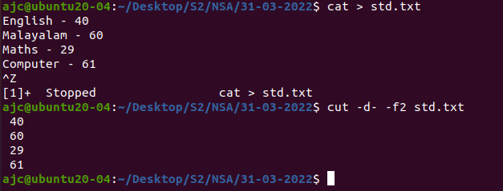

1. **cut -b ‘position’ [filename]:** This command is used to cut and print only the character of the specified position of each row from the file.

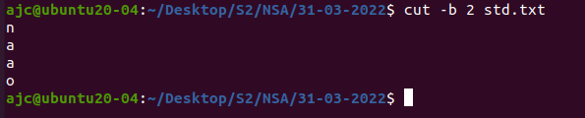

1. **cut --complement -c ‘position’ [filename]:** This command is used to cut and print the data from the file except the character from the specified position of each row.

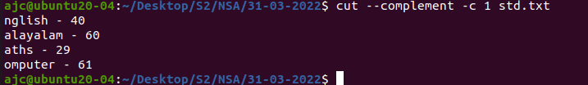

1. **paste [filename 01] [filename 02]:** This command is used to merge / paste the data from each line of a file to the corresponding line of another file.

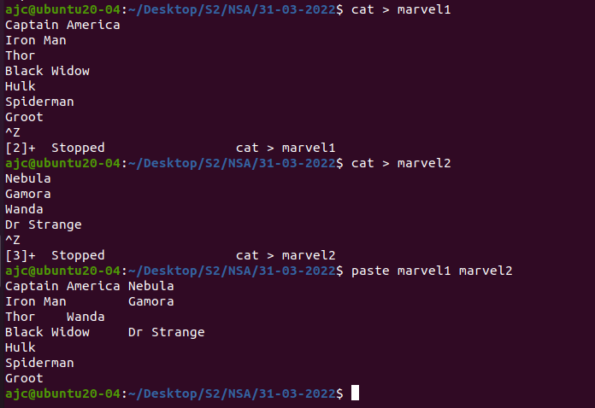

1. **paste -d’delimiter’ [filename 01] [filename 02]:** This command is used to merge / paste the data from each line of a file to the corresponding line of another file separating the data from both files using the specified delimiter.

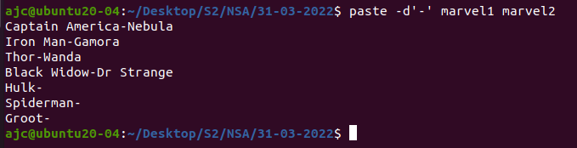

1. **paste -d ‘delimiters’ [filename 01] [filename 02] …. :** This command is used to merge / paste the data from each line of multiple files to the corresponding line of mentioned first file with each data from different files separated by the series of mentioned delimiters.  
   E.g., paste -d’-:>’ student.txt marvel1.txt marvel2.txt

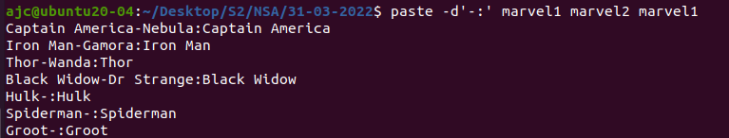

1. **paste -s [filename 01] [filename 02] …. :** This command is used to merge / paste the data of mentioned multiple files in a parallel form i.e., paste the data one file after the another.



1. **more [filename]:** This command helps to display of the large content files in a condensed or short format.

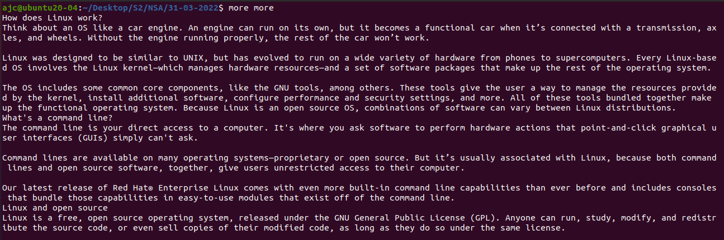

* 1. 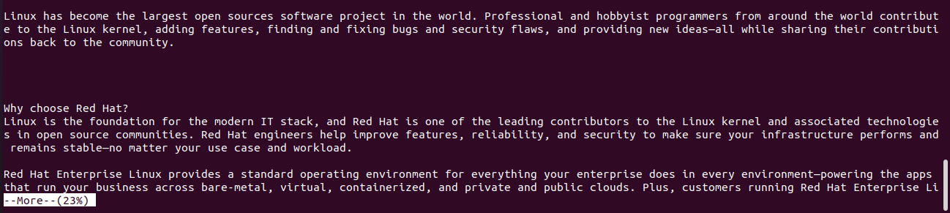**Enter Key:** While at “more” command, pressing the **Enter** Key will show the next set of data according to the percentage of shown data from the mentioned file.
  2. **Space Bar Key:** While pressing the **Space Bar**, we get to see the next set of data worth a new page from the mentioned file.
  3. **B Key:** Pressing the **B** Key will show the previous set of data i.e., to scroll back / go backward the page.

1. **more -‘number’ [filename]:** This command is used to print the data according to the mentioned number of lines from the file and with the “more %” showing the percentage of file data currently displayed.

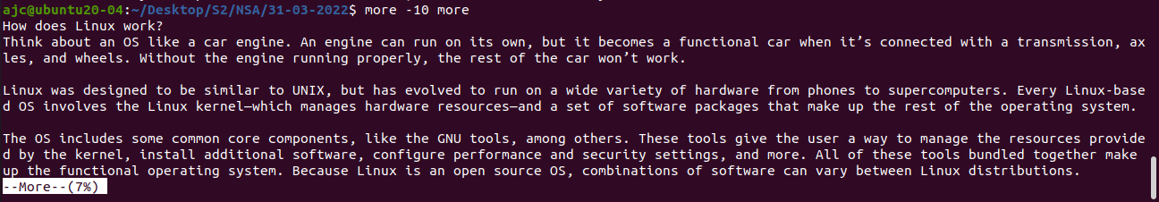

1. **more +’number’ [filename]:** This command is used to display the data from the file beginning with the mentioned line number.  
   E.g., more +3 sampletext.txt

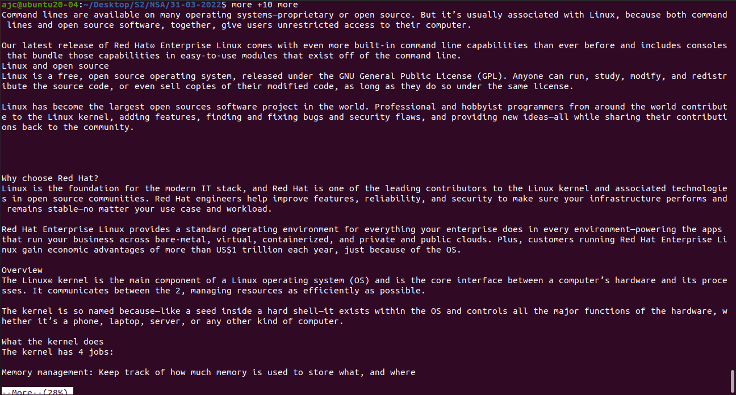

1. **more -s [filename]:** This command is used to squeeze multiple blank lines into one file and display the data from the file.



